**Subject: -Locally Debug a Serverless Application from an IDE**

* **Project By**

                                              Name: -Shruti Dash

                    Regd.no: - 170301120069

                                              Branch: -Computer Science

                                              Batch: -2017-2021

In this project, we will learn how to create a Node.js serverless application in AWS Cloud9 using AWS Lambda and Amazon API Gateway.

AWS Lambda lets you run code without provisioning or managing servers. With Lambda, you can run code for virtually any type of application or backend service - just set up your code to automatically trigger from other AWS services or call it directly from any web or mobile app.

Amazon API Gateway is a fully managed service that makes it easy for you to create, publish, maintain, monitor, and secure APIs at any scale. With API Gateway you can create an API that acts as a “front door” for AWS Lambda functions.

As a developer, there are numerous ways to build a serverless application. For those looking for a richer coding experience including capabilities such as local debugging or access to a terminal, AWS Cloud9 can help. Cloud9 is a cloud-based integrated development environment (IDE) that includes a code editor, debugger, and terminal, making it easy to write, run, and debug serverless applications with just a browser. It preconfigures the development environment with all the SDKs, libraries, and plug-ins needed for serverless development. Cloud9 also provides an environment for locally debugging AWS Lambda functions. This allows you to iterate on your code directly, saving you time, and improving the quality of your code.

In this example, we will use Cloud9 to build a serverless date and time application. You will create the application, add source code to the function, then use the Cloud9 debugger to walk through the function and its corresponding API. After using Cloud9 to run the function and API locally you will deploy the function and the API to production and test it. After testing out the function and the API in production you will modify the source in Cloud9 and deploy your changes. Finally, you will clean up and delete your resources.

Application Architecture

This application development project uses [AWS Cloud9](https://aws.amazon.com/cloud9/), [AWS Lambda](https://aws.amazon.com/lambda/" \t "_blank), [Amazon API Gateway](https://aws.amazon.com/apigateway/" \t "_blank) as pictured below:

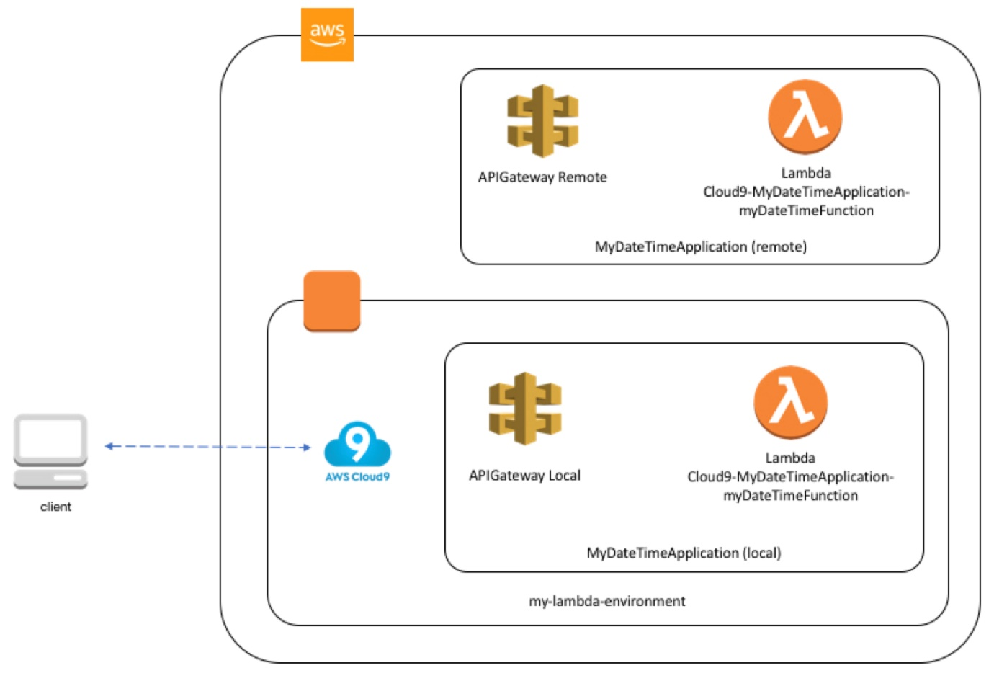

Fig.1

Technologies used:

* An Active AWS Account
* AWS Cloud9
* AWS Lambda
* Amazon API Gateway

## Steps:

* [Create and Open the Environment](https://docs.aws.amazon.com/cloud9/latest/user-guide/tutorial-lambda-create-environment.html)
* [Create the Lambda Function and API](https://docs.aws.amazon.com/cloud9/latest/user-guide/tutorial-lambda-create-function.html)
* [Add Code to the Function](https://docs.aws.amazon.com/cloud9/latest/user-guide/tutorial-lambda-add-code.html)
* [Run or Debug the Function Locally](https://docs.aws.amazon.com/cloud9/latest/user-guide/tutorial-lambda-run-or-debug-local-function.html)
* [Run or Debug the API Locally](https://docs.aws.amazon.com/cloud9/latest/user-guide/tutorial-lambda-run-or-debug-local-api.html)
* [Run the Function in Production](https://docs.aws.amazon.com/cloud9/latest/user-guide/tutorial-lambda-run-deployed-function.html)
* [Run the API in Production](https://docs.aws.amazon.com/cloud9/latest/user-guide/tutorial-lambda-run-deployed-api.html)
* [Change the Function and Deploy the Change](https://docs.aws.amazon.com/cloud9/latest/user-guide/tutorial-lambda-change-and-deploy.html)
* [Clean Up](https://docs.aws.amazon.com/cloud9/latest/user-guide/tutorial-lambda-clean-up.html)

# **Step 1: Create and Open the Environment**

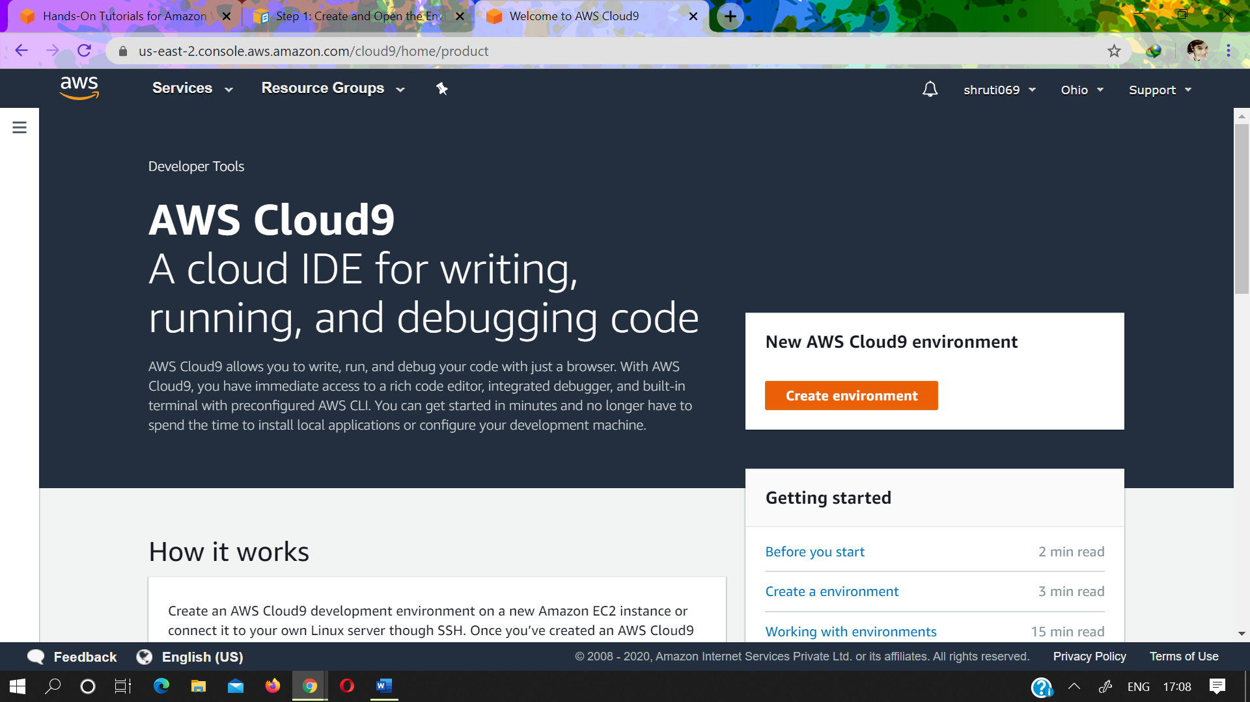

* Sign in to the AWS Cloud9 console as follows
* After you sign in to the AWS Cloud9 console, in the top navigation bar, choose an AWS Region to create the environment in. For a list of available AWS Regions, see [AWS Cloud9](https://docs.aws.amazon.com/general/latest/gr/rande.html" \l "cloud9_region) in the *AWS General Reference*.
* Choose the large **Create environment** button in one of the locations shown below.If you have no AWS Cloud9 environments yet, the button is shown on a welcome page.
* On the **Name environment** page, for **Name**, enter a name for your environment. For this project, use my-lambda-environment.
* For **Description**, enter something about your environment. For this project, use This environment is for the AWS Cloud9 project for Lambda.
* Choose **Next step**.

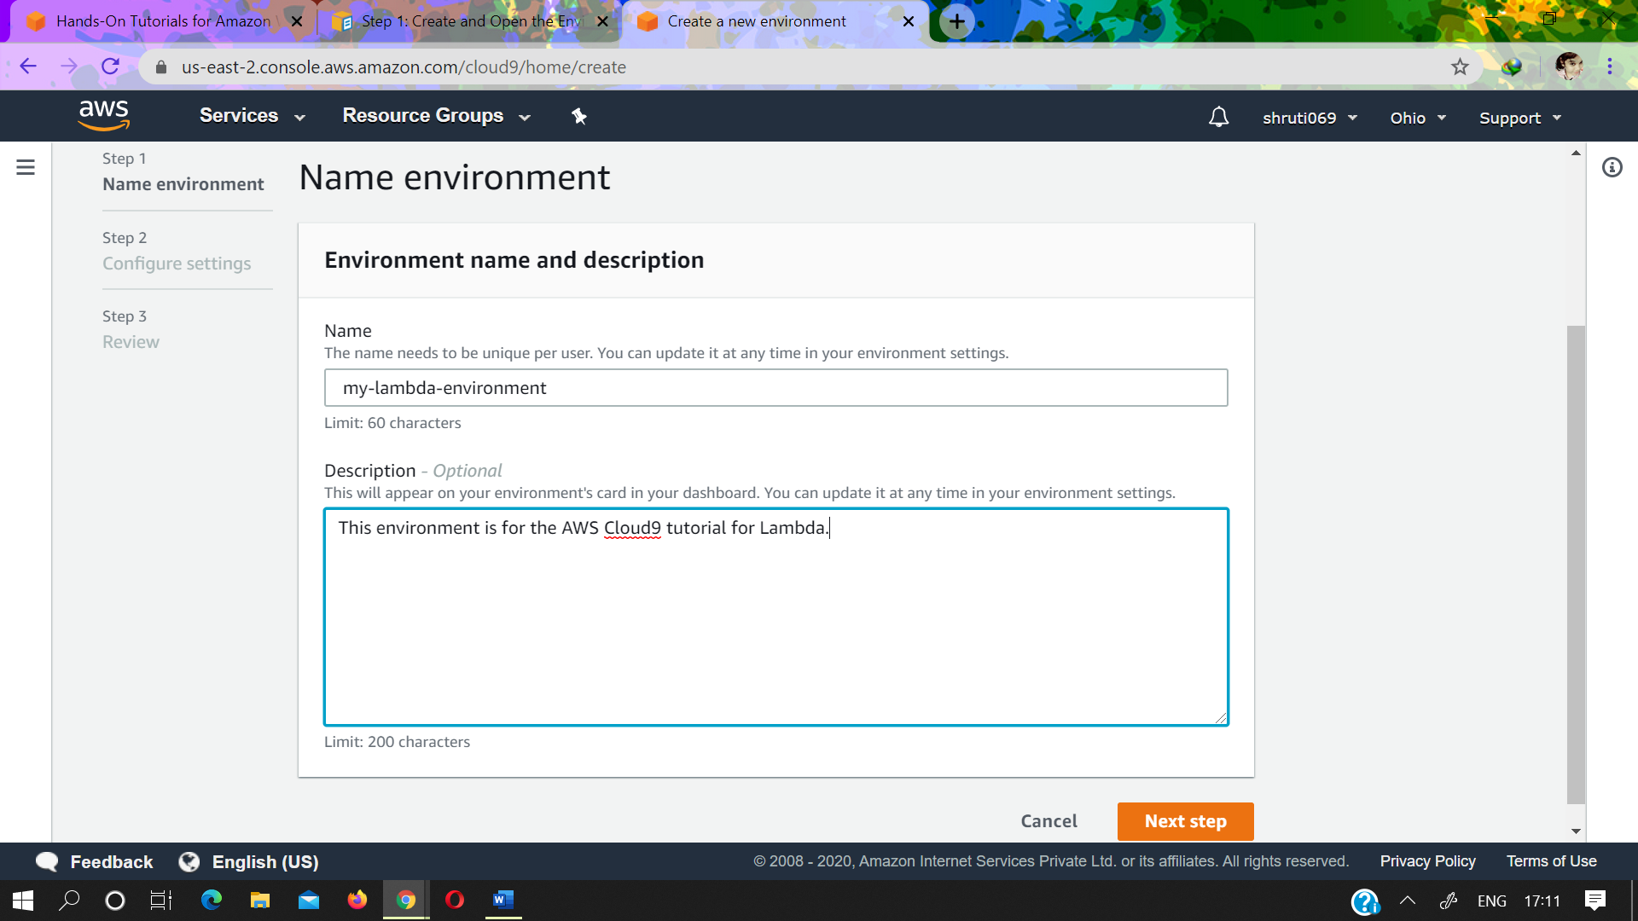

* On the **Configure settings** page, for **Environment type**, choose **Create a new instance for environment (EC2)**.
* For **Instance type**, leave the default choice. This choice has relatively low RAM and vCPUs, which is sufficient for this project.

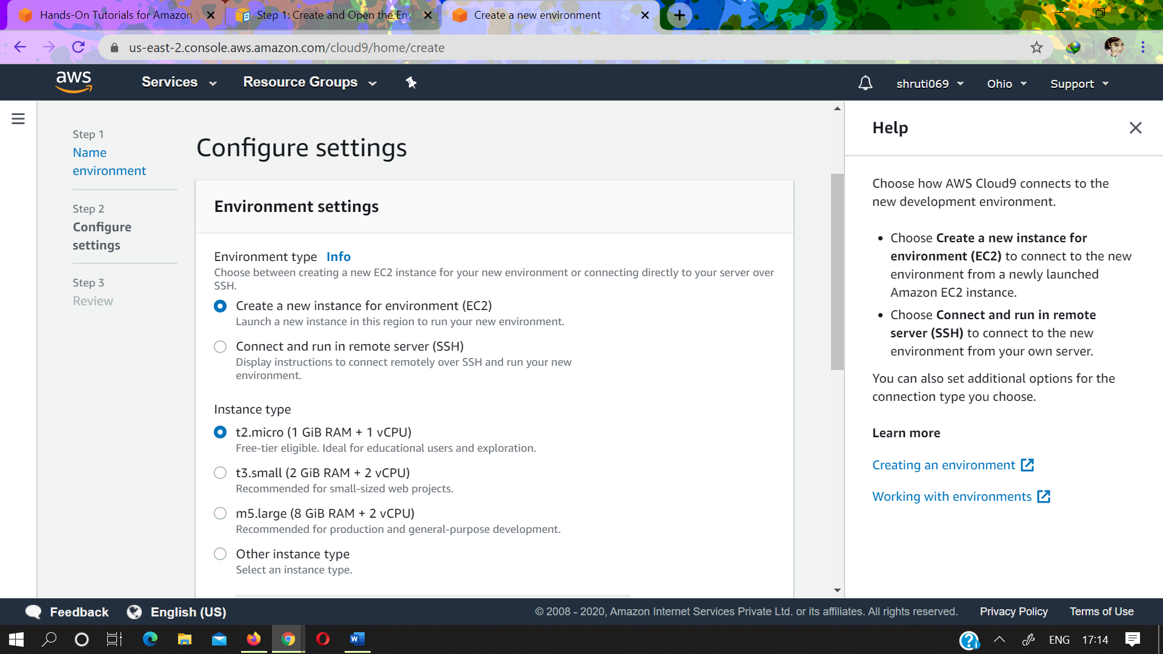

* For **Platform**, choose the type of Amazon EC2 instance that you want: **Amazon Linux** or **Ubuntu**. AWS Cloud9 creates the instance and then connects the environment to it.
* Choose a value for **Cost-saving setting**. When all web browser instances that are connected to the IDE for the environment are closed, AWS Cloud9 waits this amount of time and then shuts down the Amazon EC2 instance for the environment.

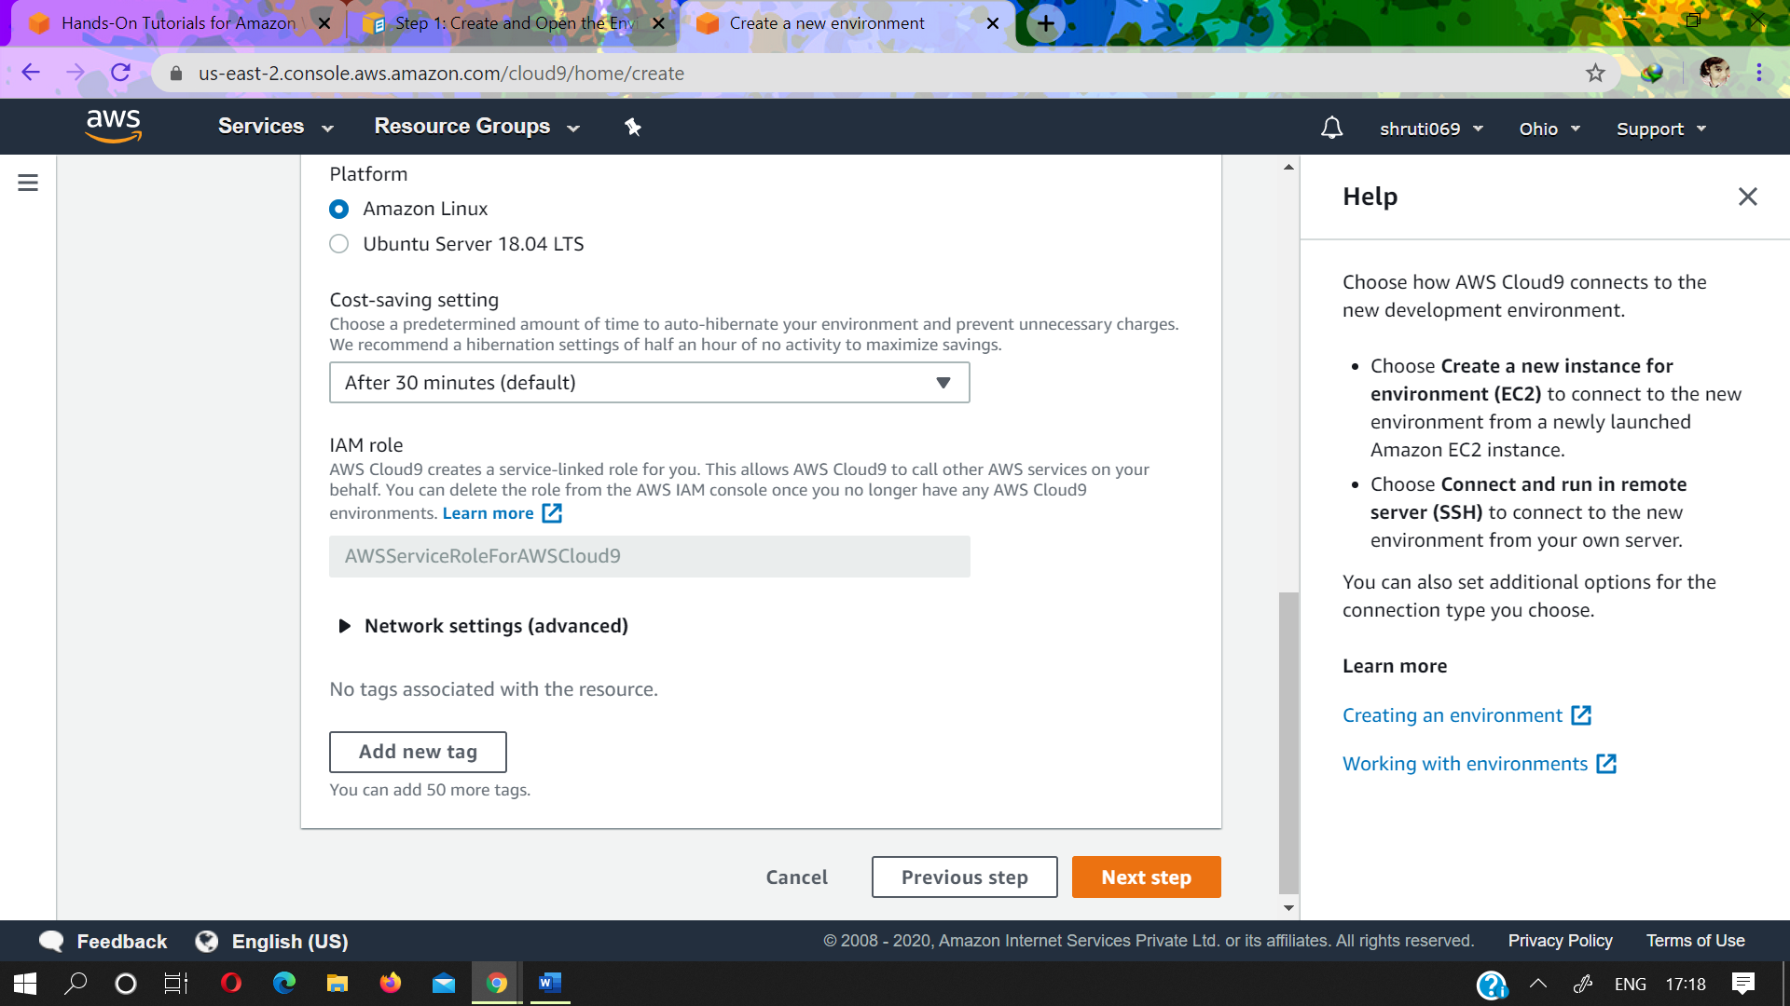

* Add up to 50 tags by supplying a **Key** and a **Value** for each tag. The tags will be attached to the AWS Cloud9 environment as resource tags, and are propagated to the following underlying resources: the AWS CloudFormation stack, the Amazon EC2 instance, and Amazon EC2 security groups. You can find information about tags in [Control Access Using AWS Resource Tags](https://docs.aws.amazon.com/IAM/latest/UserGuide/access_tags.html) in the *[IAM User Guide](https://docs.aws.amazon.com/IAM/latest/UserGuide/)*. Also see the [advanced information](https://docs.aws.amazon.com/cloud9/latest/user-guide/tags.html) about tags.
* Choose **Next step**.

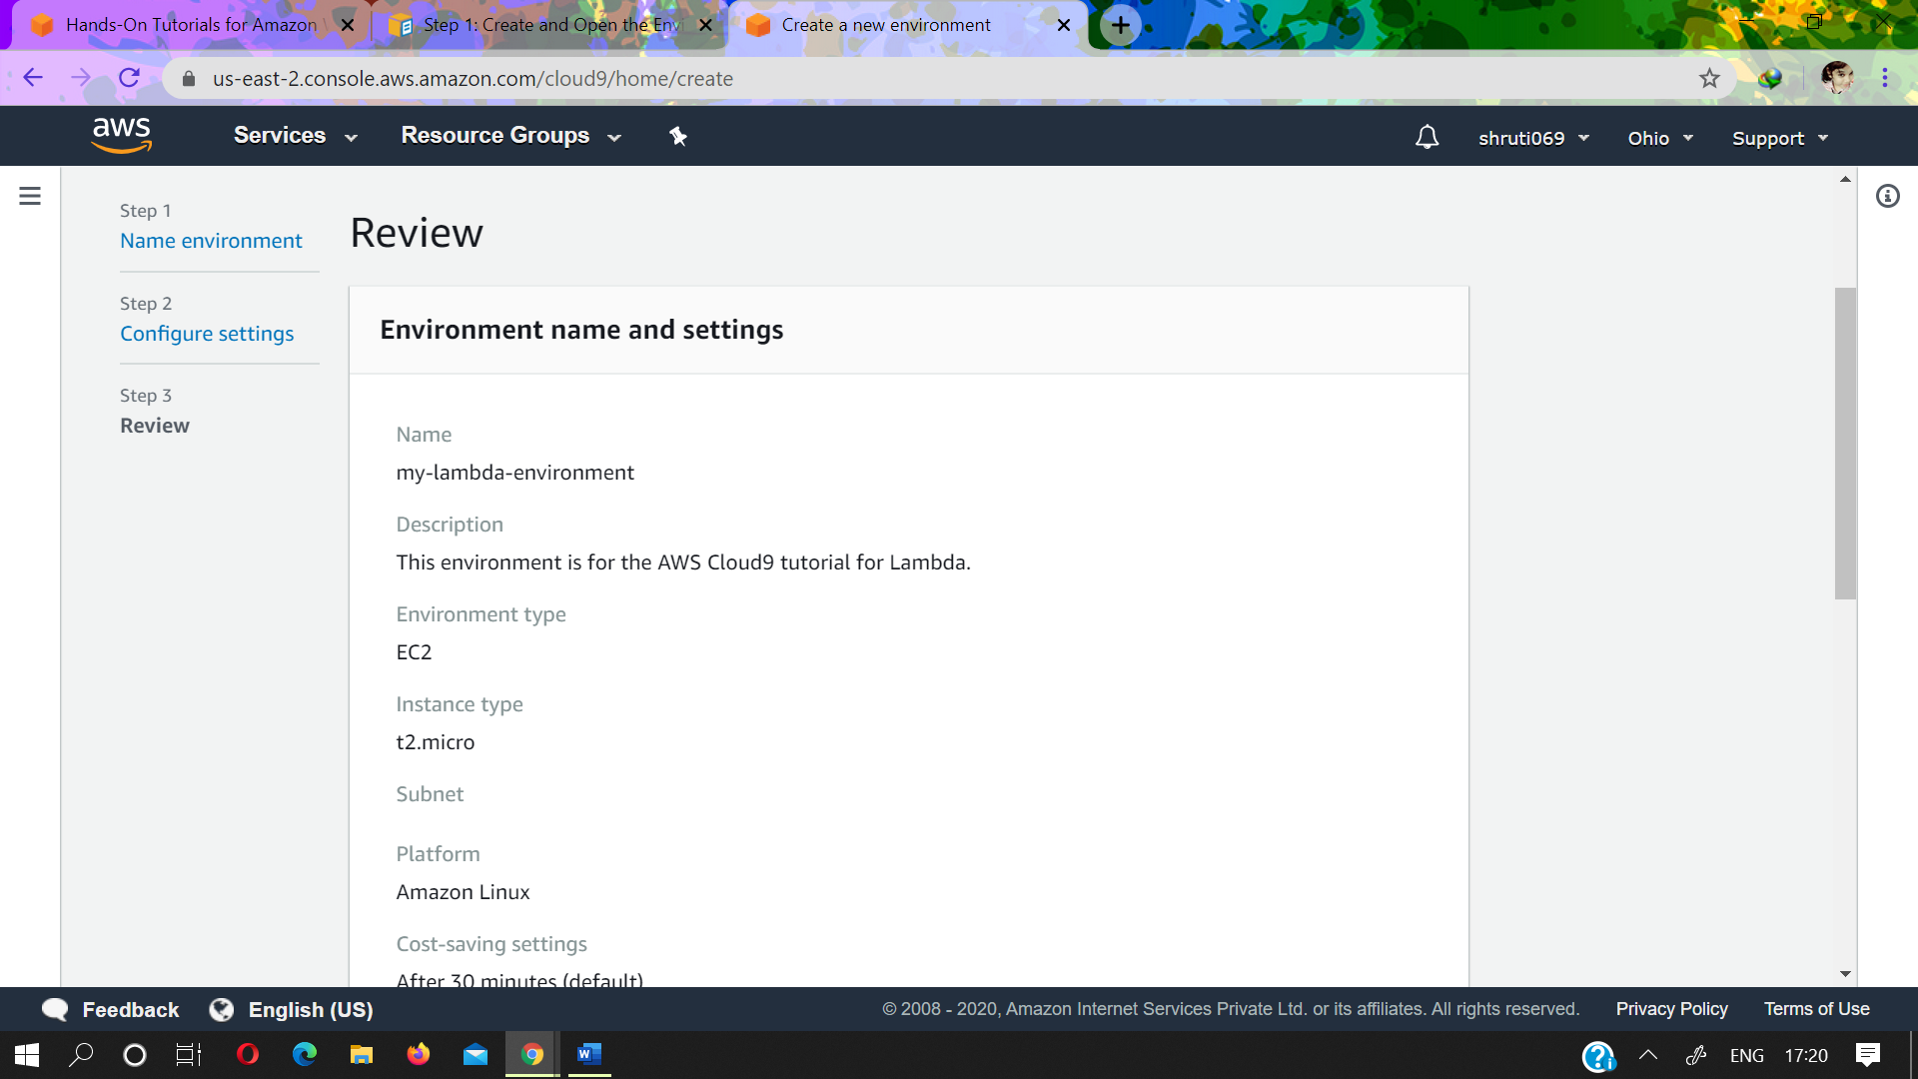

* On the **Review** page, choose **Create environment**. Wait while AWS Cloud9 creates your environment. This can take several minutes.

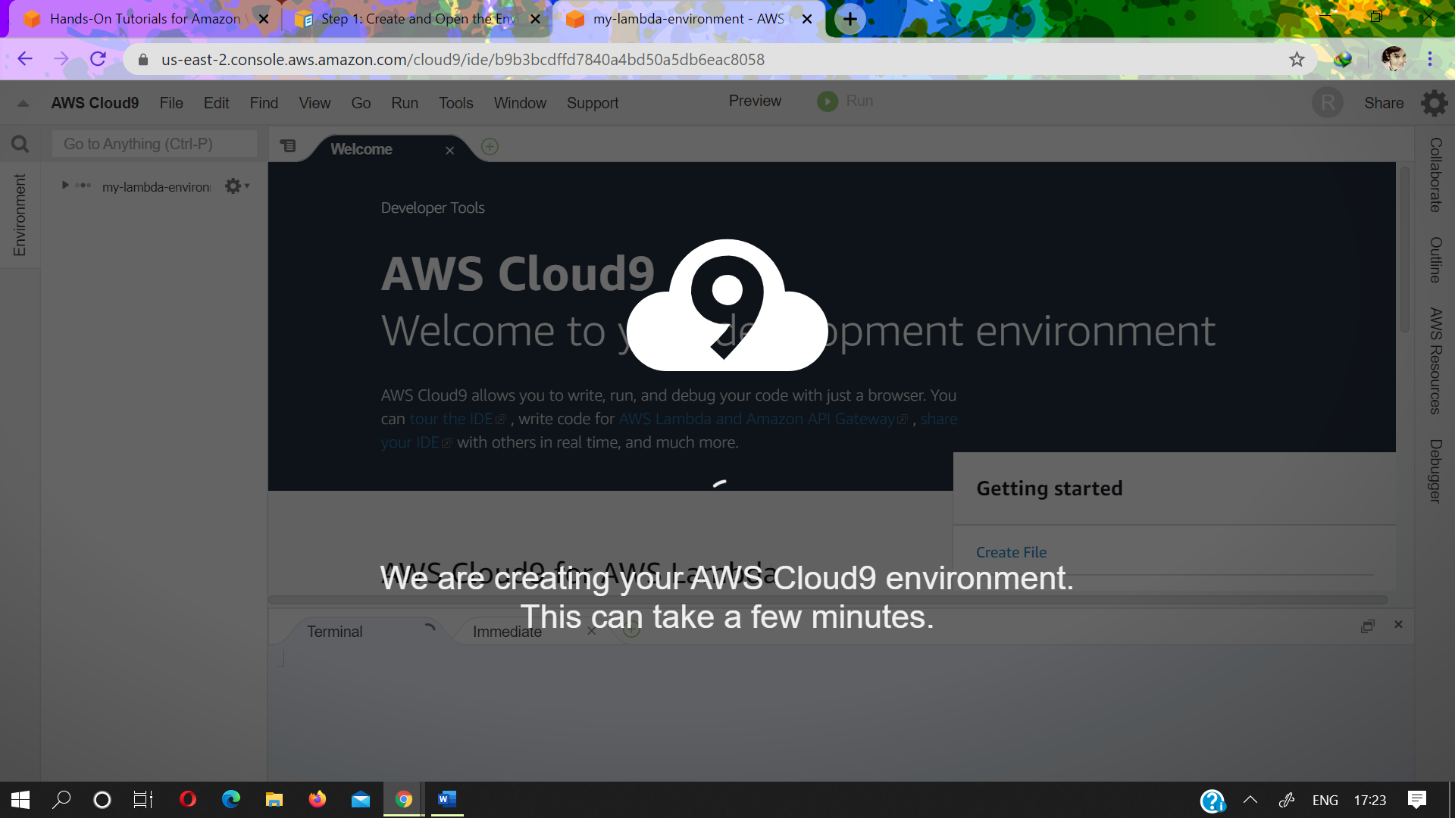

# **Step 2: Create the Lambda Function and API**

1. Make sure you have completed the prerequisites for work with Lambda functions in the AWS Cloud9 IDE for the environment. This includes checking to see whether you must:
   * Set up your IAM group with required access permissions.
   * Set up your environment with AWS access credentials.
   * Create an execution rule for your Lambda functions.

For more information, see [Prepare to Work with Lambda Functions](https://docs.aws.amazon.com/cloud9/latest/user-guide/lambda-functions.html" \l "lambda-functions-prepare).

1. With the IDE open from the previous step, set the AWS Region that you want to create the function in. To do this, on the menu bar, choose **AWS Cloud9, Preferences**.
2. In the navigation pane of the **Preferences** tab, choose **AWS Settings**.
3. For **AWS Region**, select the AWS Region you want to create the function in.

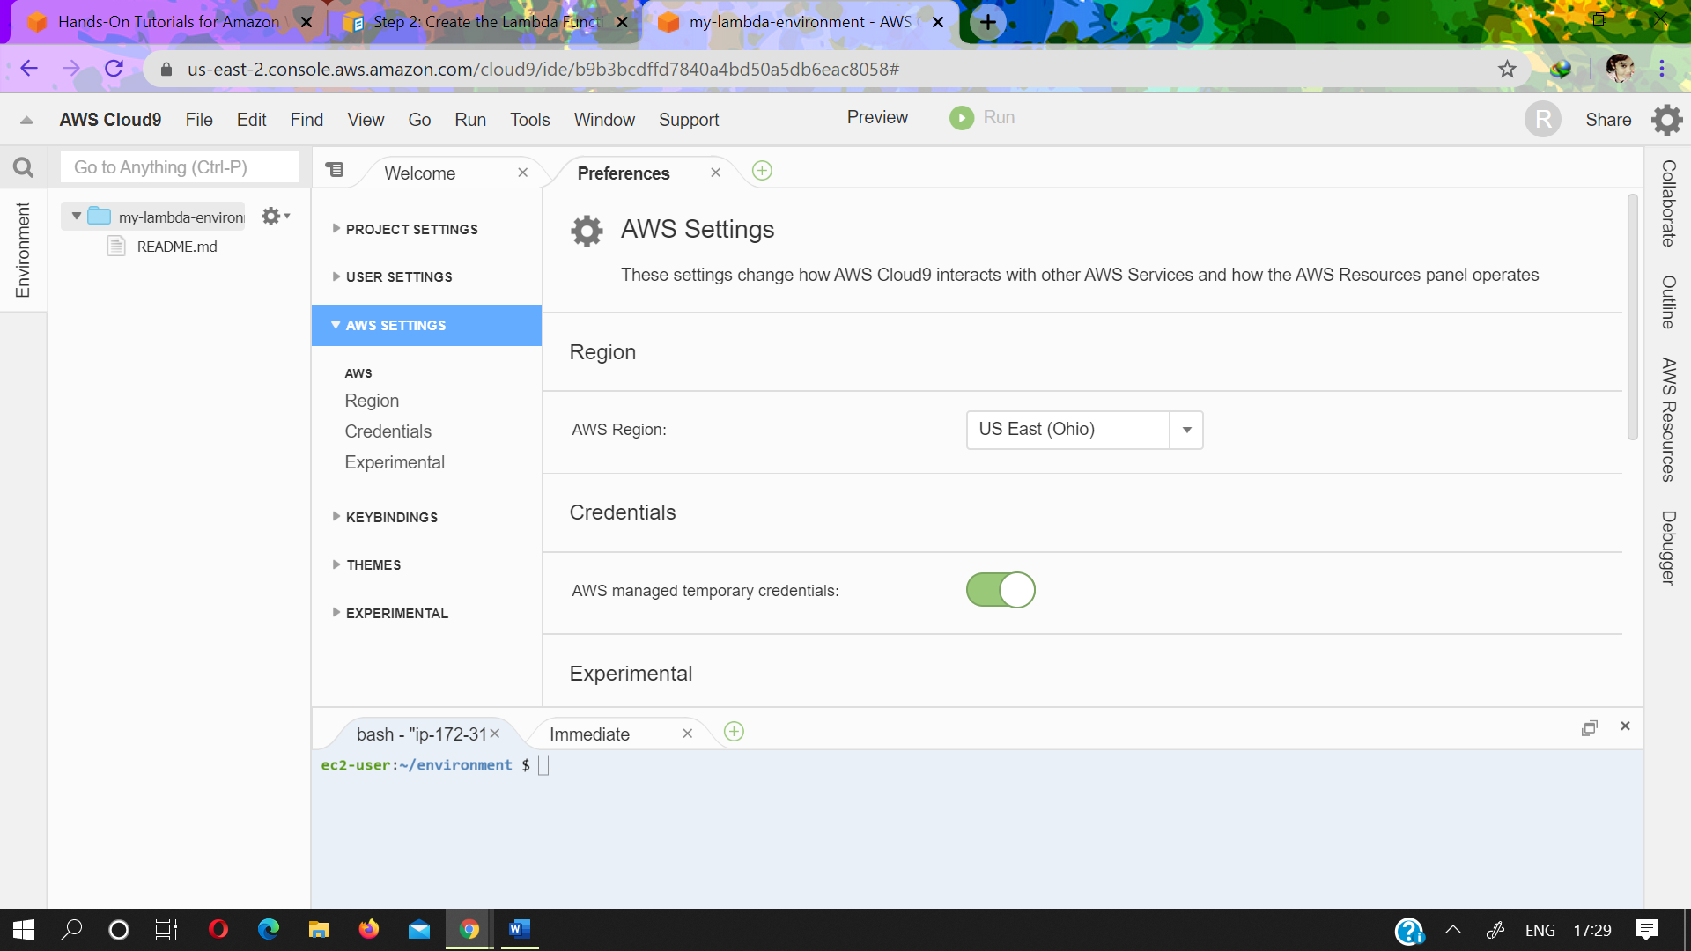

On the edge of the IDE, choose **AWS Resources**.

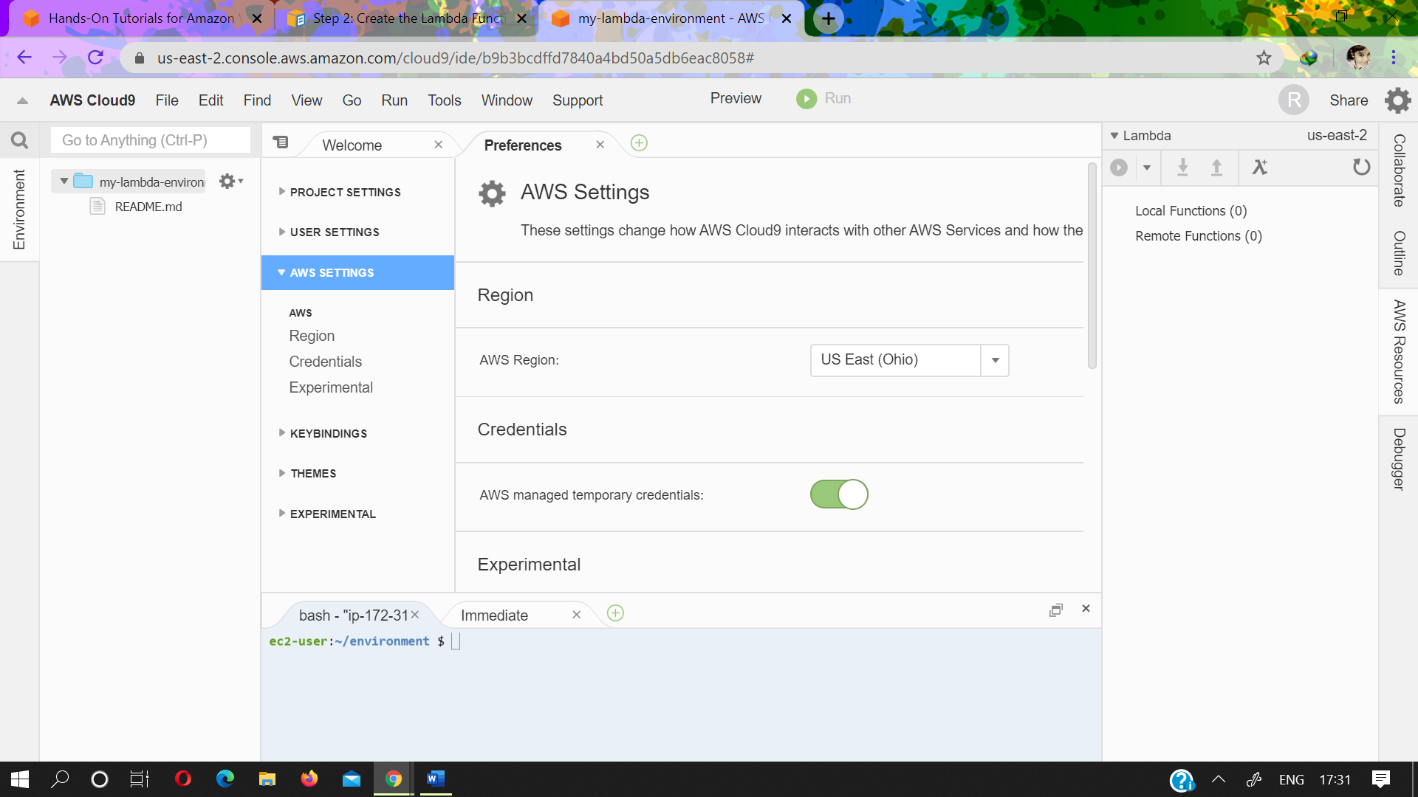Expand the **Lambda**, if it isn't already expanded. On the toolbar, choose the **Create a new Lambda function** icon.

* + In the **Create serverless application** dialog box, for **Function name**, type a name for the function (for example, myDateTimeFunction).
  + For **Application name**, type a name for the function's containing serverless application (for example, MyDateTimeApplication).
  + Choose **Next**.

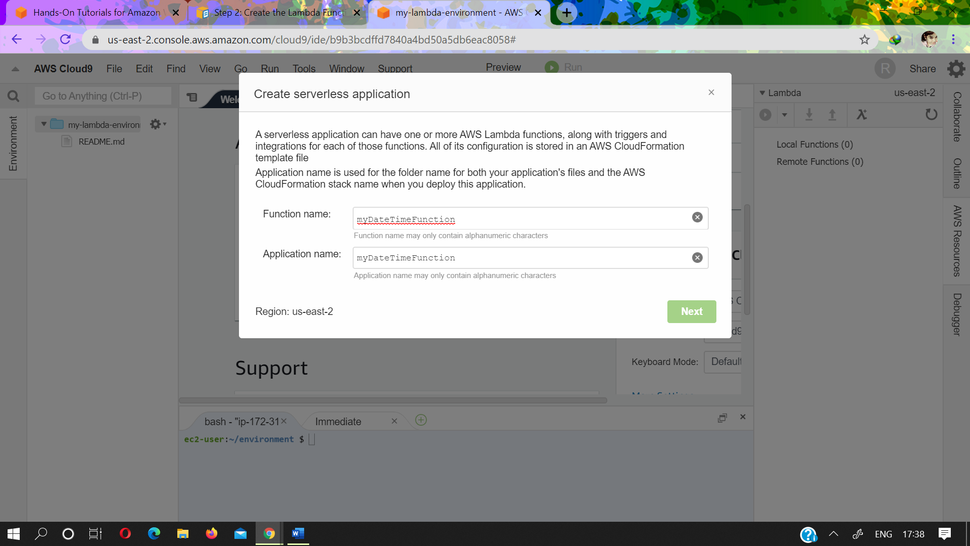

* + For **Select runtime**, choose **Node.js 6.10**.
  + For **Select blueprint**, choose **empty-nodejs**. This creates some starter code that you work with in the next step.
  + Choose **Next**.

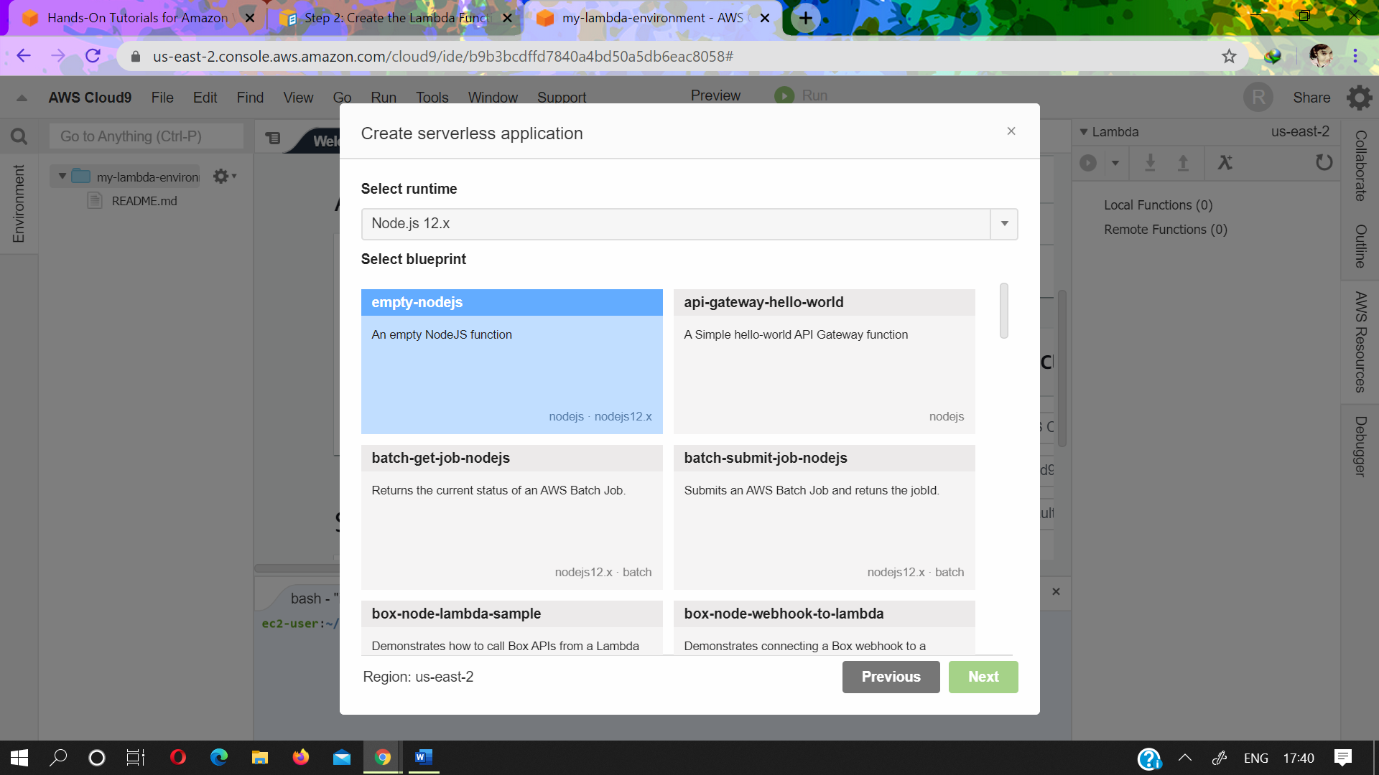

* + For **Function trigger**, choose **API Gateway**. This creates an API in API Gateway that you use to run and debug the function in a later step.
  + For **Resource Path**, type / (a forward slash). The **Resource Path** defines a portion of the URL that you use to run and debug the API in a later step. For more information, see [Set up API Methods in API Gateway](https://docs.aws.amazon.com/apigateway/latest/developerguide/how-to-method-settings.html) in the API Gateway Developer Guide.
  + For **Security**, choose **NONE**, and then choose **Next**. This specifies that you don't need any special credentials to run and debug this API.

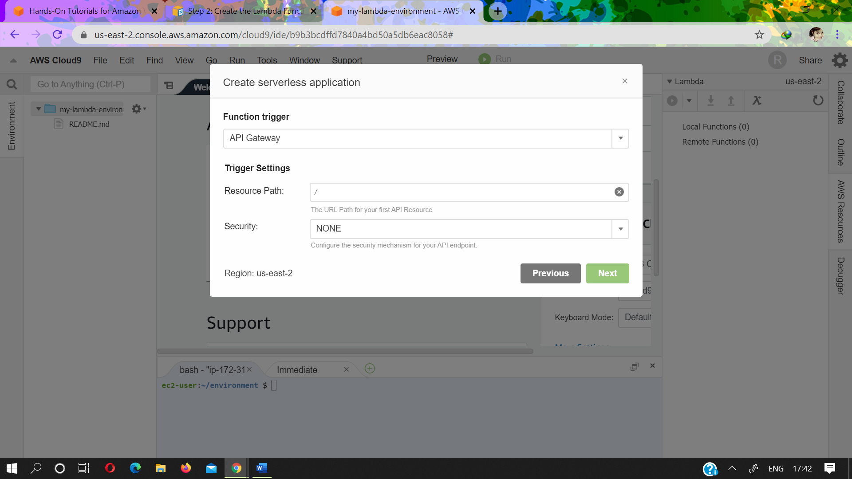

* + For **Memory (MB)**, leave the default value of **128 MB**, which is sufficient for this project.
  + For **Role**, leave the default value of **Automatically generate role**, and then choose **Next**. This specifies the access permissions that the function needs to work properly.

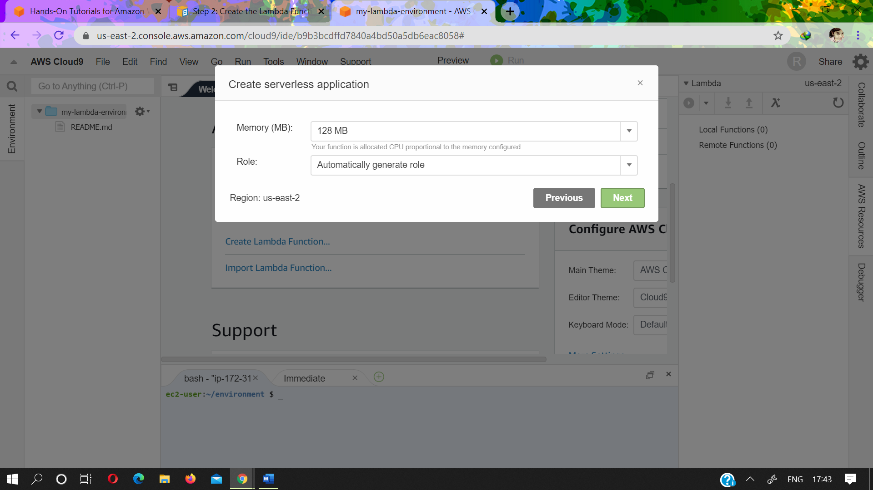

* Review your choices, and then choose **Finish**.

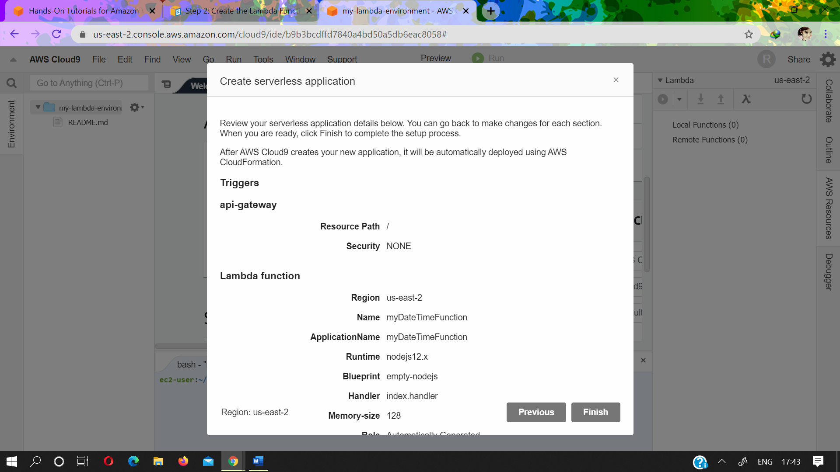

AWS Cloud9 creates the function and its related API on the instance. Then it deploys a copy of the function and API to Lambda and API Gateway. The serverless application and function are displayed in the **Local Functions** and **Remote Functions** lists in the **Lambda** pane of the **AWS Resources** window. The serverless application's and function's component files are displayed in the **Environment** window. The editor opens the function's code file, index.js.

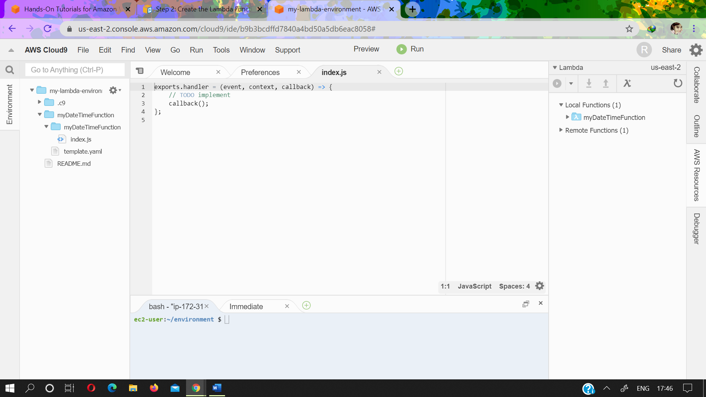

# **Step 3: Add Code to the Function**

In this step, you replace the starter code for the generated function with specific code that returns information about the day or time you specify.With the index.js file already open in the editor,completely replace the file's contents with the following code, and then savethefile.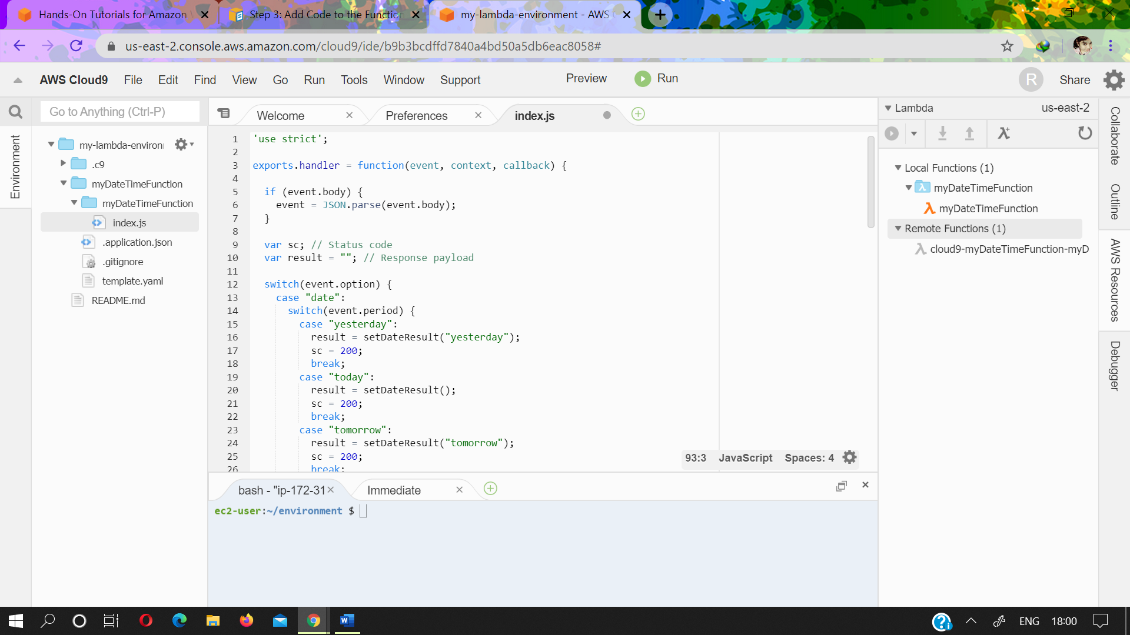

Code are

'use strict';

exports.handler = function(event, context, callback) {

if (event.body) {

event = JSON.parse(event.body);

}

var sc; // Status code

var result = ""; // Response payload

switch(event.option) {

case "date":

switch(event.period) {

case "yesterday":

result = setDateResult("yesterday");

sc = 200;

break;

case "today":

result = setDateResult();

sc = 200;

break;

case "tomorrow":

result = setDateResult("tomorrow");

sc = 200;

break;

default:

result = {

"error": "Must specify 'yesterday', 'today', or 'tomorrow'."

};

sc = 400;

break;

}

break;

case "time":

var d = new Date();

var h = d.getHours();

var mi = d.getMinutes();

var s = d.getSeconds();

result = {

"hour": h,

"minute": mi,

"second": s

};

sc = 200;

break;

default:

result = {

"error": "Must specify 'date' or 'time'."

};

sc = 400;

break;

}

const response = {

statusCode: sc,

headers: { "Content-type": "application/json" },

body: JSON.stringify( result )

};

callback(null, response);

function setDateResult(option) {

var d = new Date(); // Today

var mo; // Month

var da; // Day

var y; // Year

switch(option) {

case "yesterday":

d.setDate(d.getDate() - 1);

break;

case "tomorrow":

d.setDate(d.getDate() + 1);

default:

break;

}

mo = d.getMonth() + 1; // Months are zero offset (0-11)

da = d.getDate();

y = d.getFullYear();

result = {

"month": mo,

"day": da,

"year": y

};

return result;

}

};

This function takes an incoming payload with an option value of date or time. If date is specified, you must also specify a period value of yesterday, today, or tomorrow. The function then returns the corresponding month, day, and year. If, however, an option value of time is specified, the function returns the current hour, minute, and second.

# **Step 4: Run or Debug the Function Locally**

1. In the **Lambda** pane of the **AWS Resources** window, expand the **MyDateTimeApplication** Lambda folder, and then right-click the **myDateTimeFunction** Lambda icon.
2. Choose **Run, Run Local**.

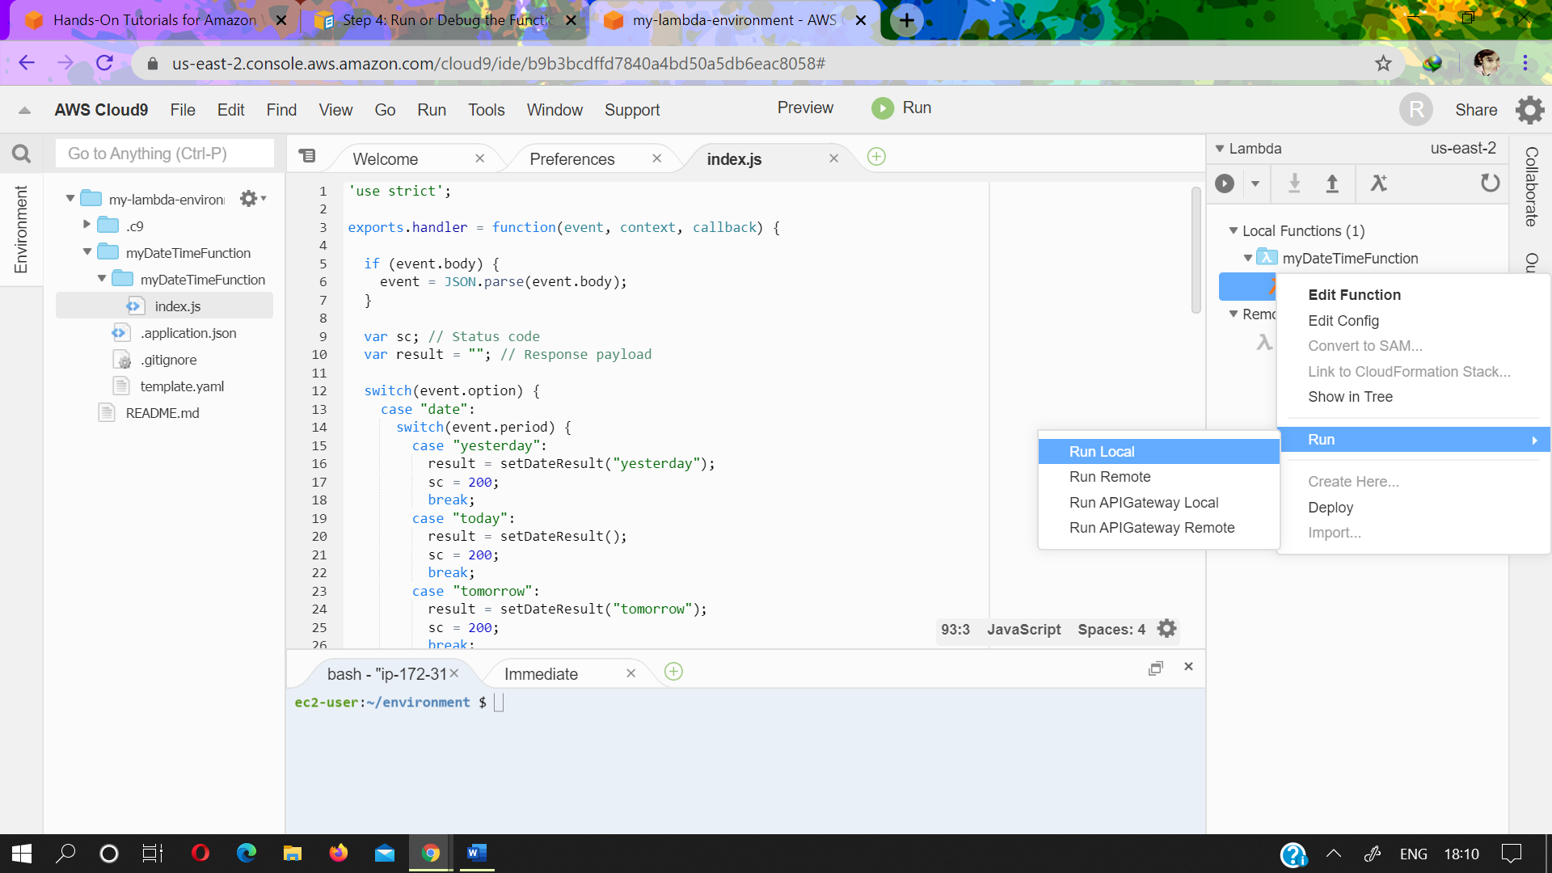

* In the **Payload** pane of the run tab, replace {} with the following, which sends this data as input to the function for processing.
* Choose **Run**.

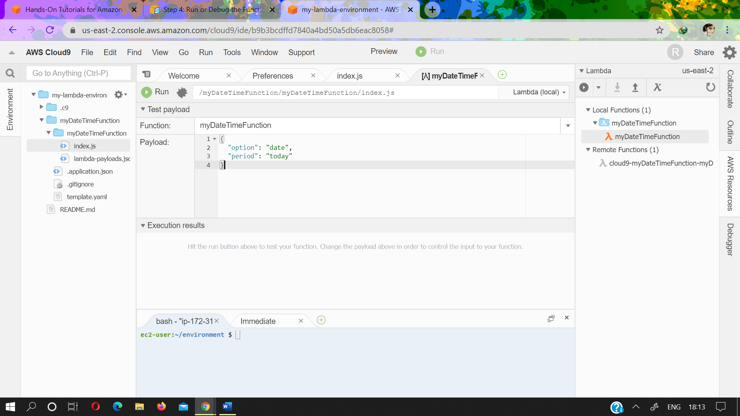

* The **Response** pane displays the following.

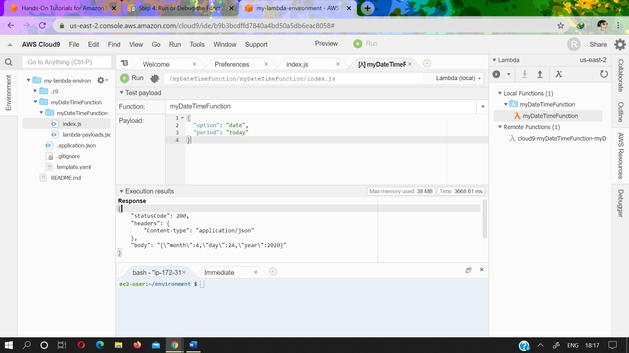

## Step 4.2: Debug the Function Locally

1. In the index.js file, create a breakpoint for the debugger. To do this, in the editor, next to the line of code callback(null, response), click the gutter just to the left of line 62. A red circle is displayed, representing the breakpoint.
2. On the right edge of the IDE, choose **Debugger**.
3. Add four expressions for the debugger to watch. To do this, in the **Watch Expressions** area, for **Type an expression here**, type event.option, and then press Enter. Do this three more times, typing event.period, sc, and response.body.

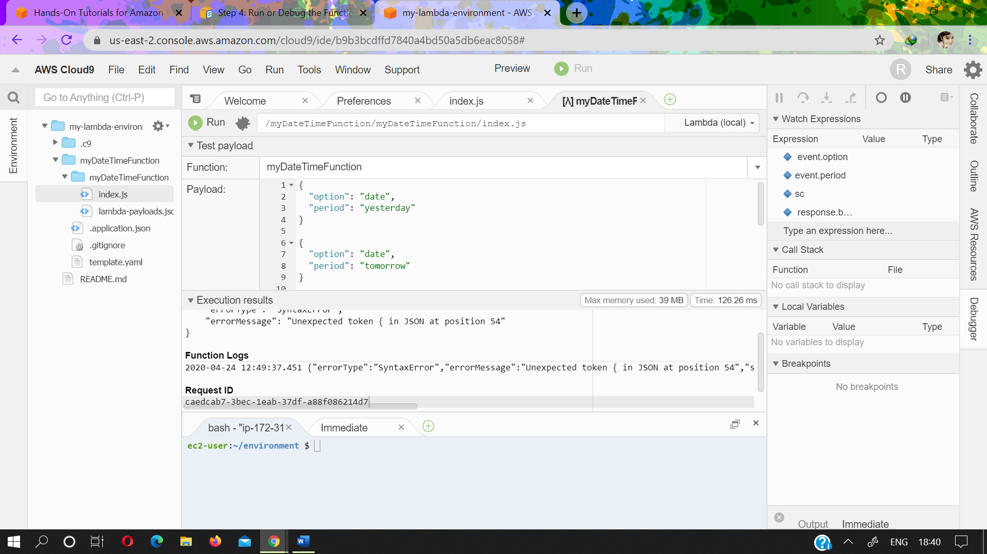

On the run tab that AWS Cloud9 opened in [Step 4.1: Run the Function Locally](https://docs.aws.amazon.com/cloud9/latest/user-guide/tutorial-lambda-run-or-debug-local-function.html" \l "tutorial-lambda-run-local-function), choose the icon that looks like a bug. (It switches from grey to green.)

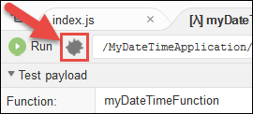

* In the **Payload** pane on the run tab, be sure the following payload is still visible.

{

"option": "date",

"period": "today"

}

Choose **Run**.

Code execution pauses at the breakpoint. The current values of event.option, event.period, sc, and response.body are displayed in the **Watch Expressions** area of the **Debugger** window.

You can also see these values in the code by hovering your mouse over option in line 12 in the code, period in line 14, sc in line 21, and response in line 56. For response in line 56, expand **Object {}**, and then see the **body** value.

# **Step 5: Run or Debug the API Locally**

* In the **Lambda** pane of the **AWS Resources** window, right-click the **myDateTimeFunction** Lambda icon, and then choose **Run, Run APIGateway Local**.

**Note**

You can also do this by choosing the **Lambda (local)** list on the run tab from the previous step, and then choosing **API Gateway (local)**.

* On the run tab, for **Path**, type / (a forward slash).
* For **Method**, choose **POST**.
* For **Body**, replace {} with the following, which sends this data as input to the API for processing.

{

"option": "date",

"period": "today"

}

* If the bug icon is green, choose it to turn it off. (It switches back to grey.)



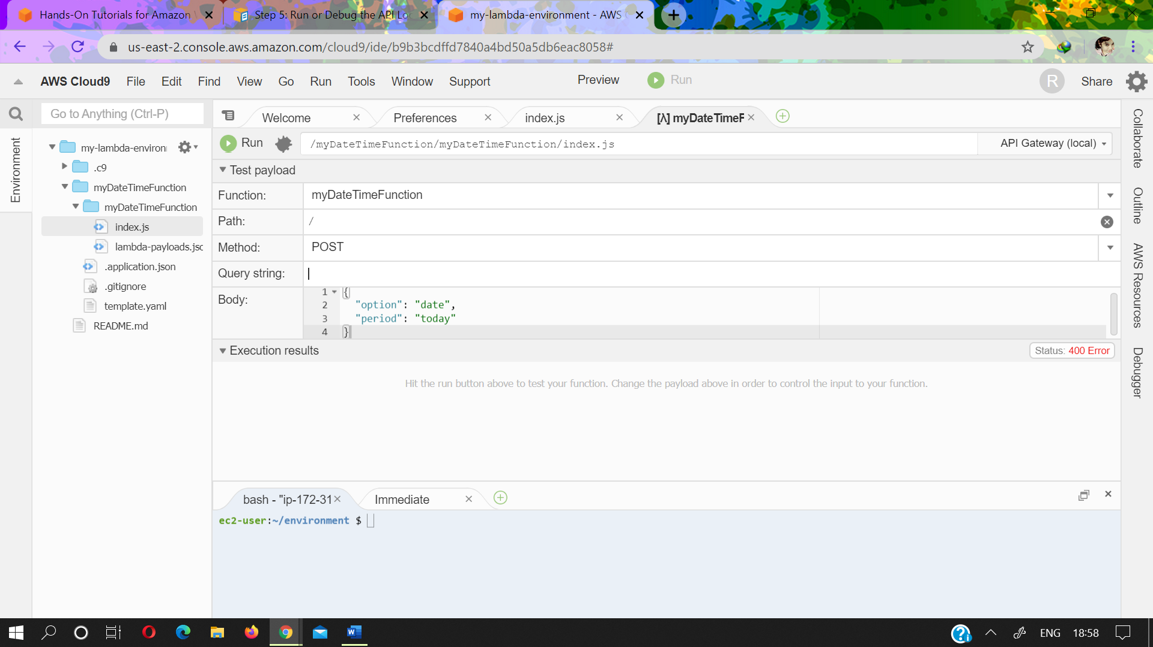

* Choose **Run**.

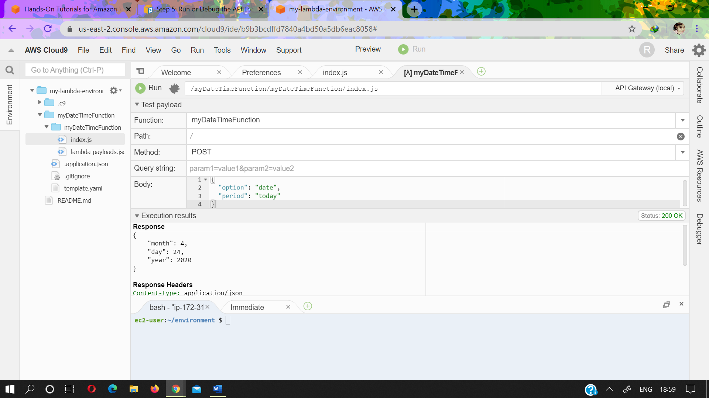

* Code execution pauses at the breakpoint, and the current values of event.option, event.period, sc, and response.body are displayed in the **Watch Expressions** area of the **Debugger** window.

You can also see these values in the code by hovering your mouse over option, period, sc, and response in the code. For response, expand **Object {}**, and then see the **body** value.

* In the Debugger window, choose the blue **Resume** arrow to finish running the code.

# **Step 6: Run the Function in Production**

1. In the **Lambda** pane of the **AWS Resources** window, expand **Local Functions**, expand the **MyDateTimeApplication** Lambda folder, right-click the **myDateTimeFunction** Lambda icon, and then choose **Deploy**.

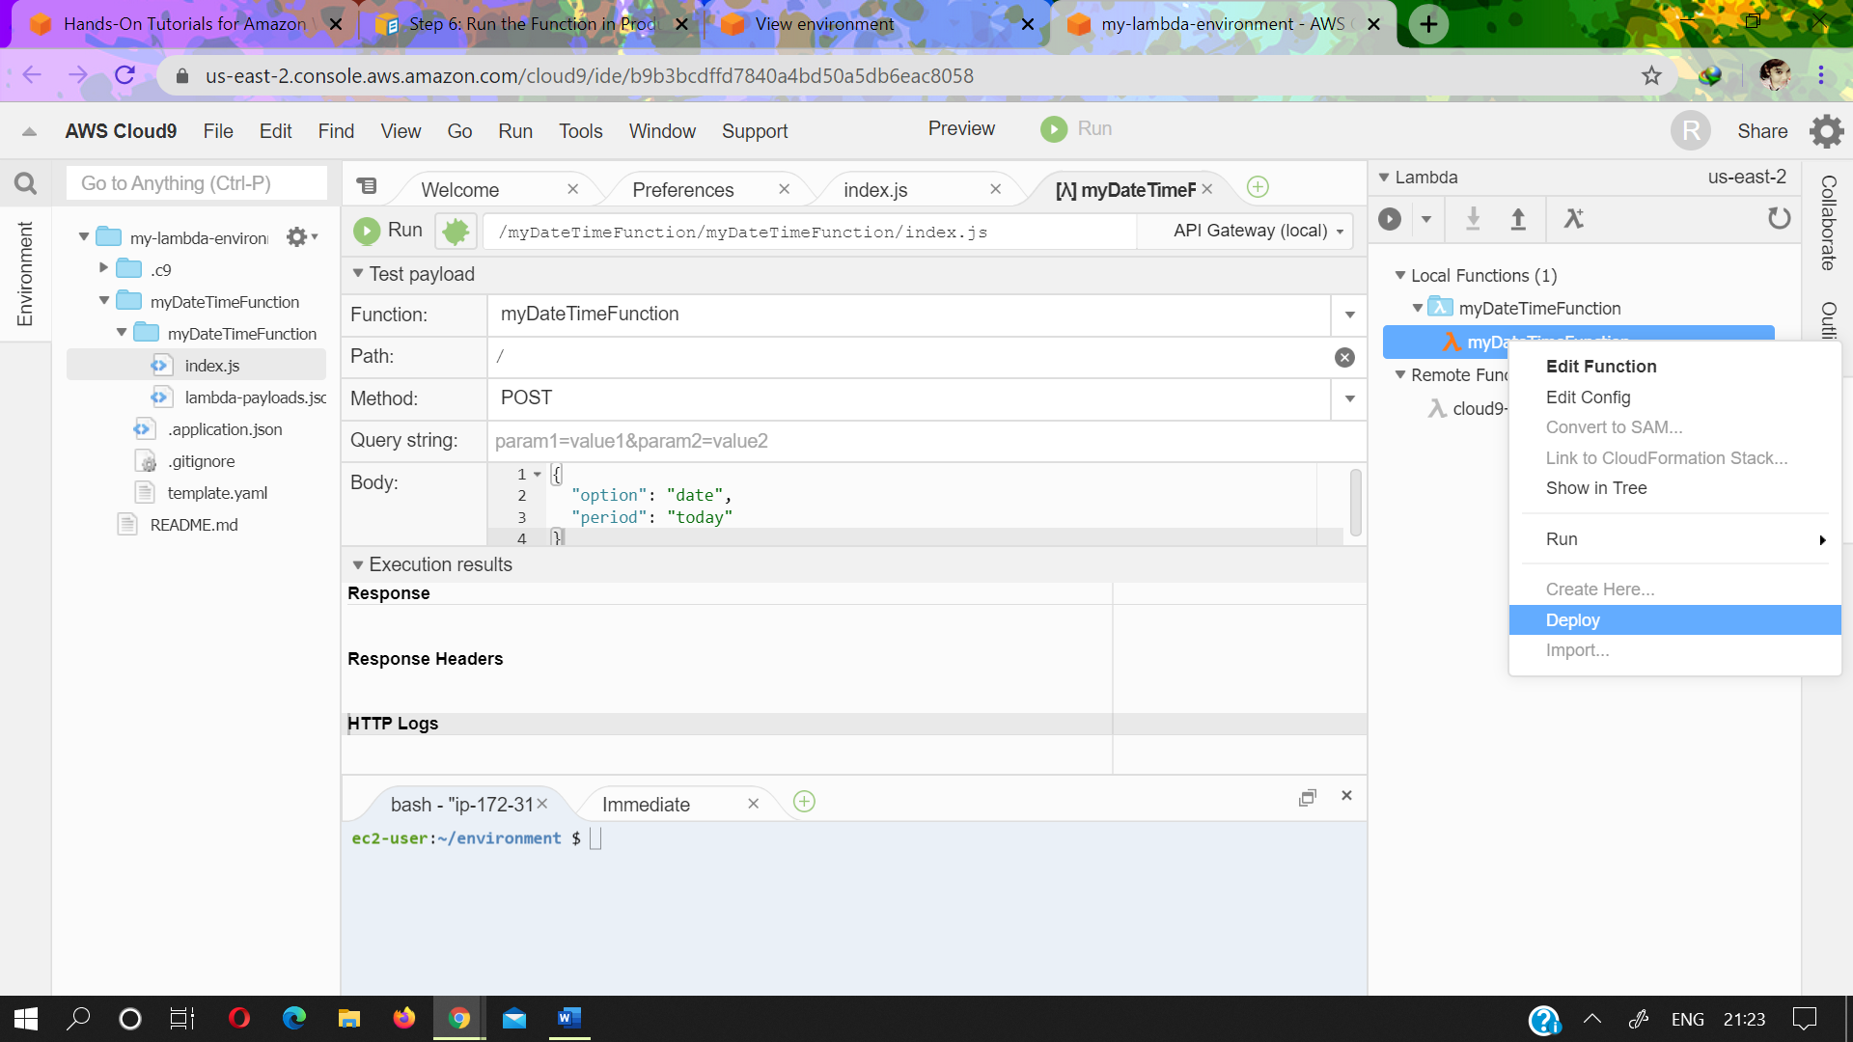

1. After the deployment finishes, right-click the **myDateTimeFunction** Lambda icon, and then choose **Run, Run Remote**.
2. In the **Payload** pane on the run tab, be sure one of the payloads from [Step 4.1: Run the Function Locally](https://docs.aws.amazon.com/cloud9/latest/user-guide/tutorial-lambda-run-or-debug-local-function.html" \l "tutorial-lambda-run-local-function) is visible. If it isn't there, add it.
3. Choose **Run**, and see the results in the **Response** area. These should be the same results as in [Step](https://docs.aws.amazon.com/cloud9/latest/user-guide/tutorial-lambda-run-or-debug-local-function.html" \l "tutorial-lambda-run-local-function)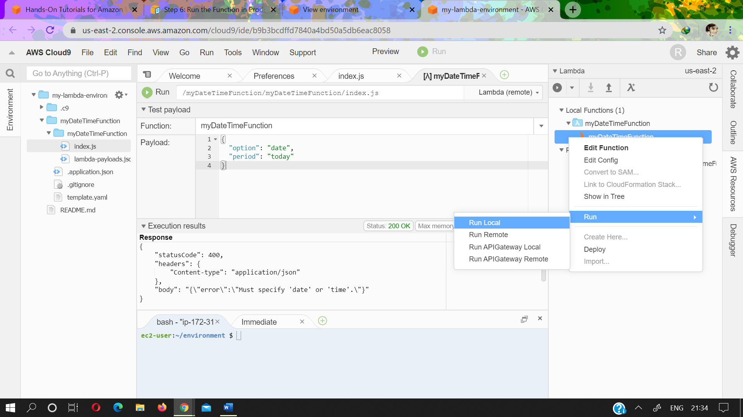

# **Step 7: Run the API in Production**

1. In the **Lambda** pane of the **AWS Resources** window, right-click the **myDateTimeFunction** Lambda icon, and then choose **Run, Run APIGateway Remote**.
2. Ensure **Path** is still set to **/**, **Method** is still set to **POST**, and **Body** is still set to one of the bodies in [Step 5.1: Run the API Locally](https://docs.aws.amazon.com/cloud9/latest/user-guide/tutorial-lambda-run-or-debug-local-api.html" \l "tutorial-lambda-run-local-api). If any of these aren't set correctly, set them.
3. Choose **Run**, and see the results in the **Response** area, which should be the same results as in [Step 5.1: Run the API Locally](https://docs.aws.amazon.com/cloud9/latest/user-guide/tutorial-lambda-run-or-debug-local-api.html" \l "tutorial-lambda-run-local-api).

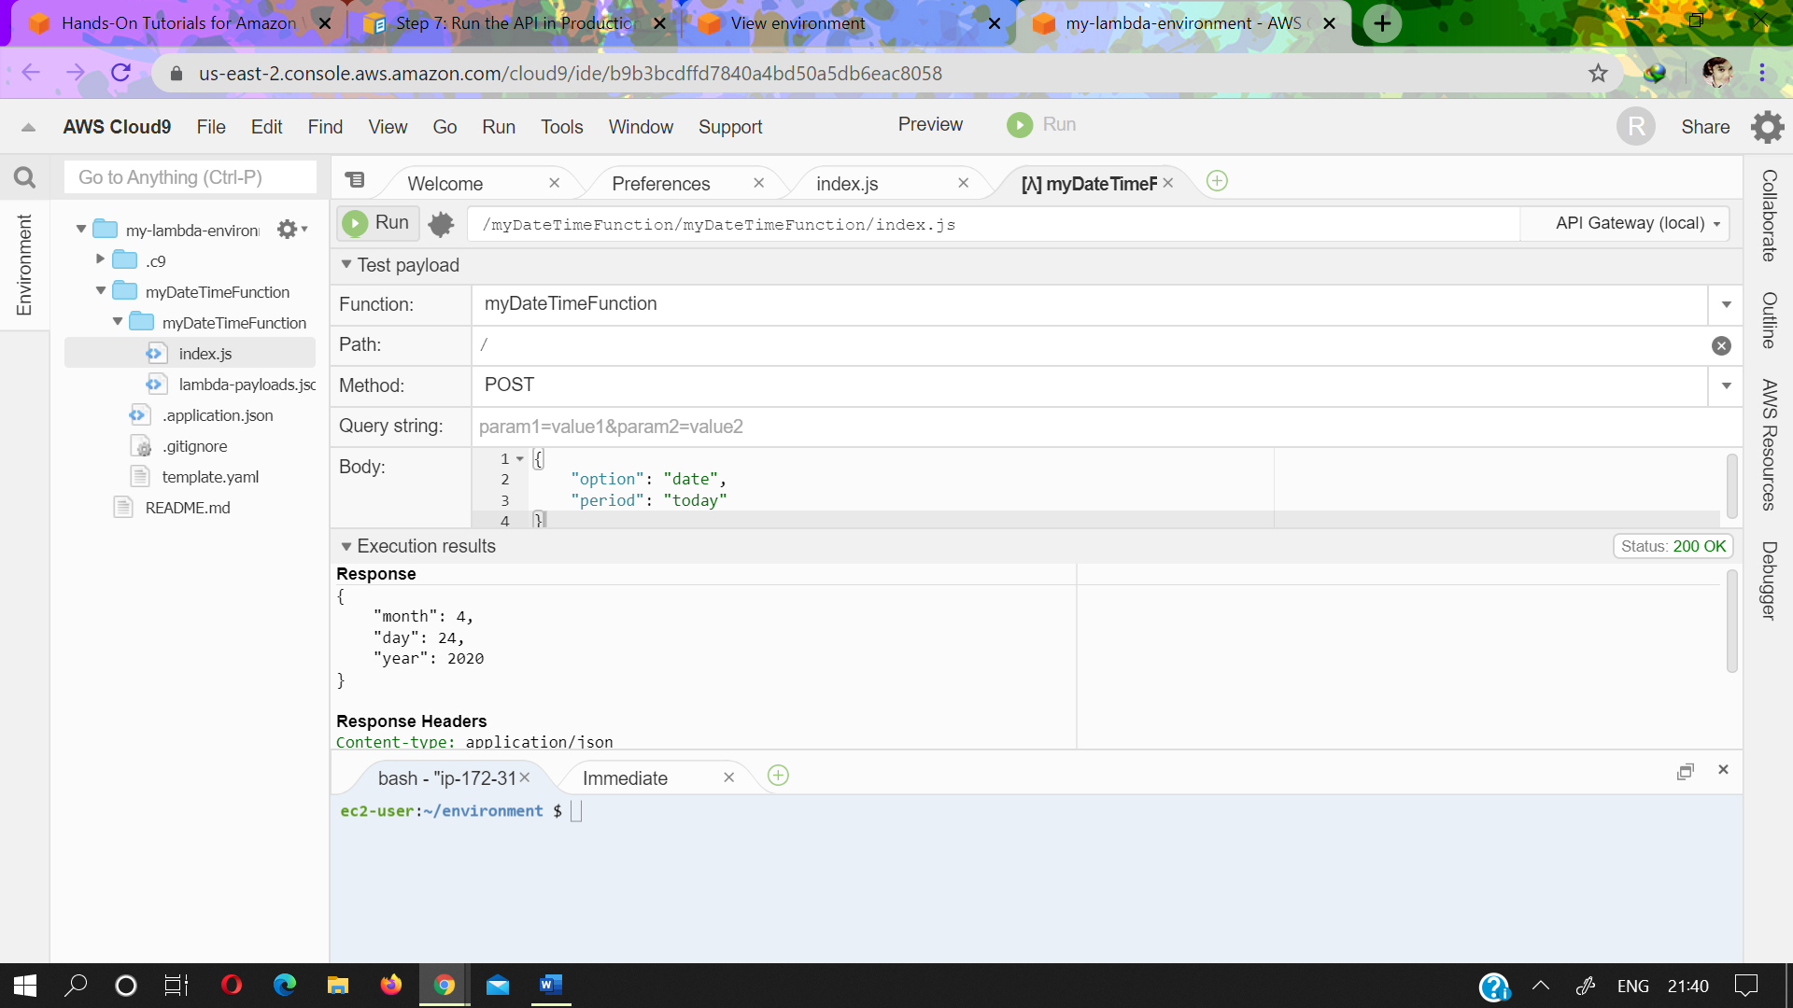

# **Step 8: Change the Function and Deploy the Change**

* In the index.js file, on line 41, add a time value to the result variable, as follows.

result = {

"time": d.toTimeString(),

"hour": h,

"minute": mi,

"second": s

};

* On line 86, add a date value to the result variable, as follows.

result = {

"date": d.toDateString(),

"month": mo,

"day": da,

"year": y

};

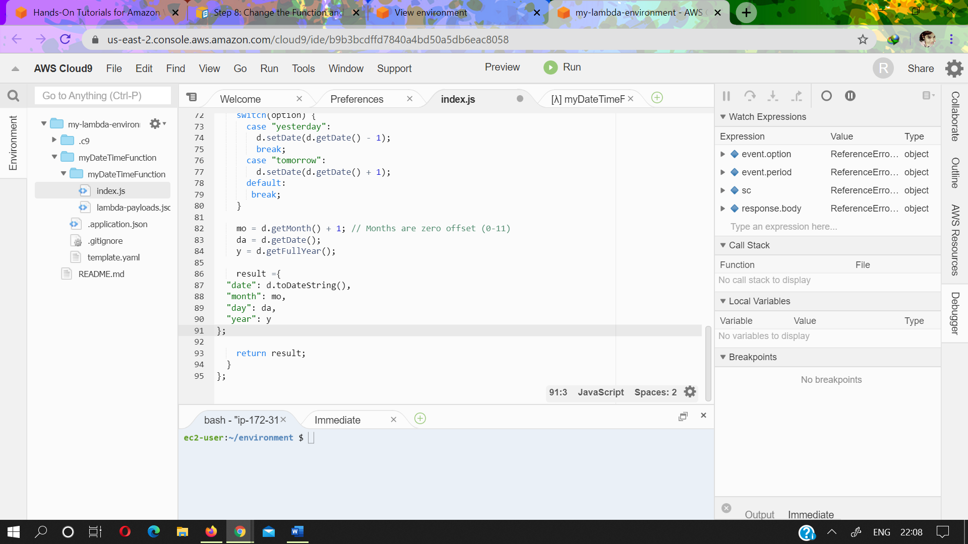

* Save your changes to the index.js file.
* Run the changed function locally by following the instructions in [Step 4.1: Run the Function Locally](https://docs.aws.amazon.com/cloud9/latest/user-guide/tutorial-lambda-run-or-debug-local-function.html" \l "tutorial-lambda-run-local-function). Notice that the time or date value is now displayed in the response. 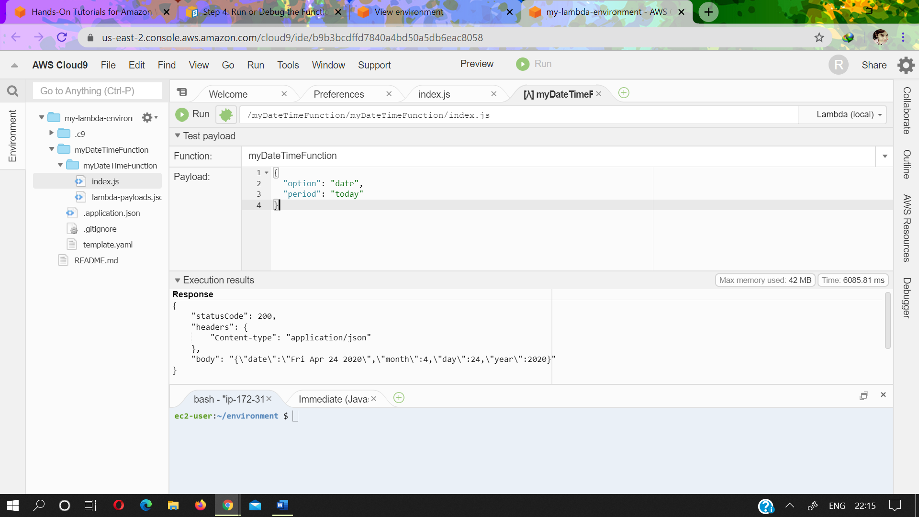
* Run the original function in production by following the instructions in [Step 6: Run the Function in Production](https://docs.aws.amazon.com/cloud9/latest/user-guide/tutorial-lambda-run-deployed-function.html). Notice that the time or date value doesn't display in the response yet. This is because you have not deployed the changed function into production. You do this in the next step.

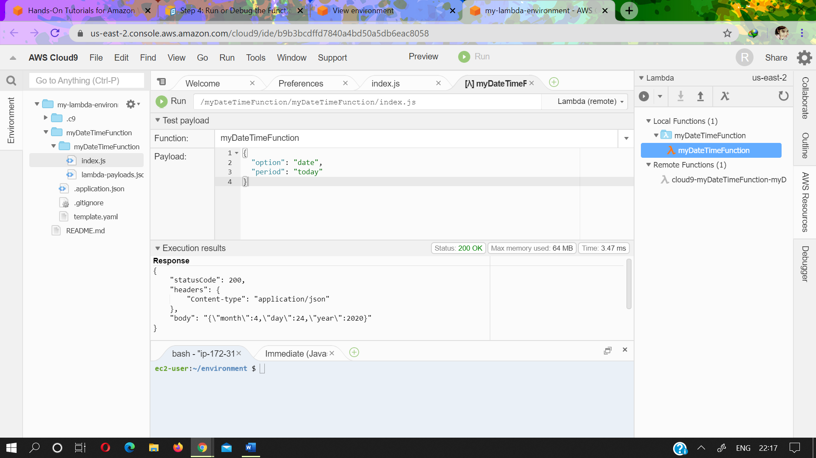

## Step 8.2: Deploy the Changed Function into Production

In this step, you deploy the changed function again to Lambda itself. You then test the changed function in production to confirm the deployment.

1. In the **Lambda** pane of the **AWS Resources** window, right-click the **myDateTimeFunction** Lambda icon, and then choose **Deploy**.
2. After the deployment succeeds, run the changed function in production by following the instructions in [Step 6: Run the Function in Production](https://docs.aws.amazon.com/cloud9/latest/user-guide/tutorial-lambda-run-deployed-function.html). Notice that the time or date value now appears in the response.

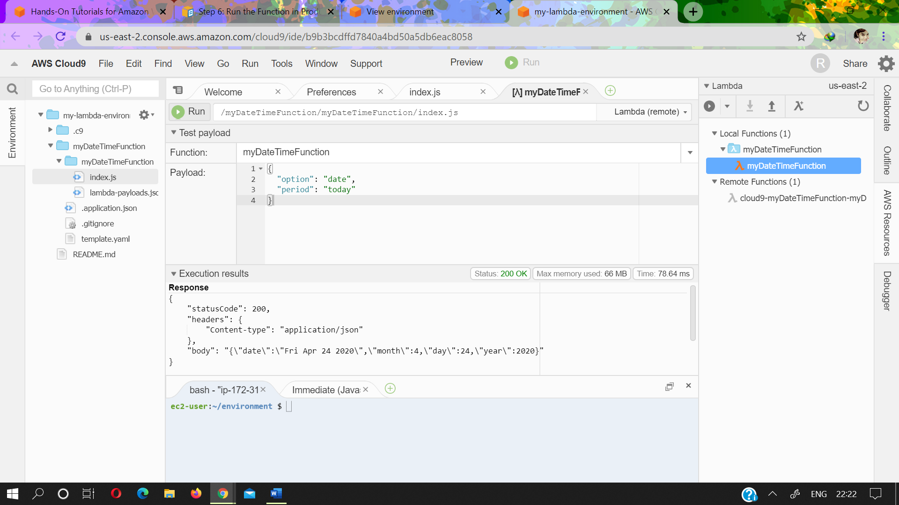

# **Step 9: Clean Up**

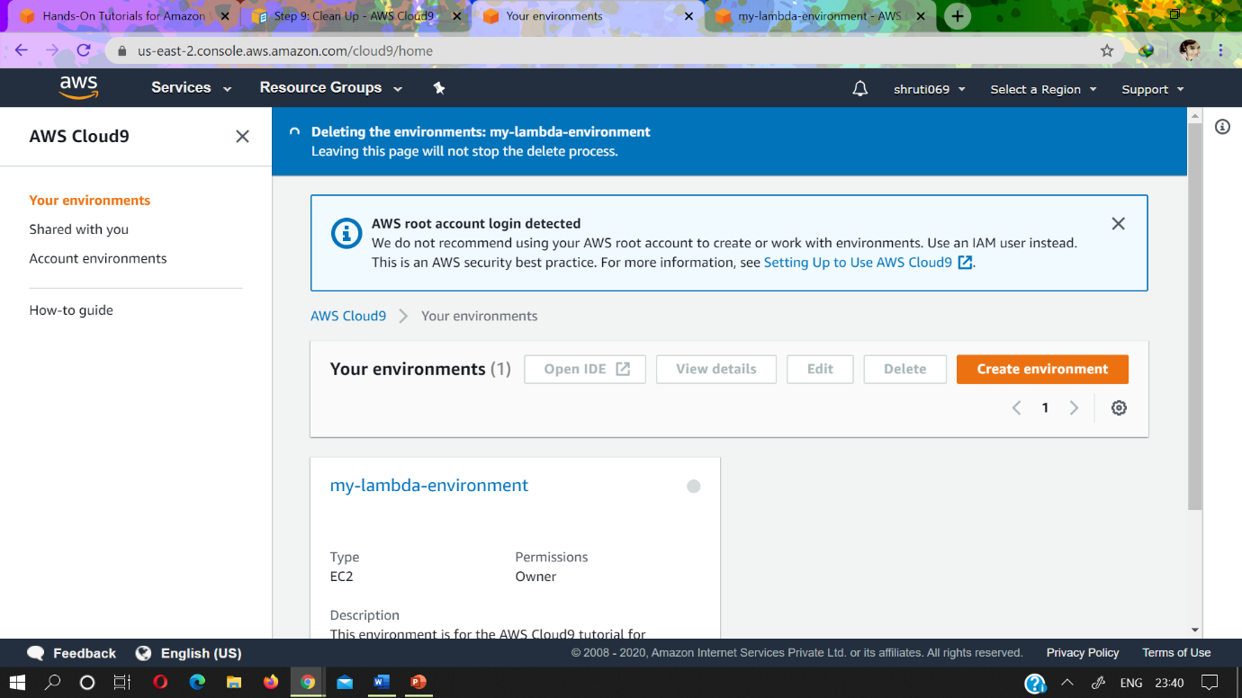

ENDS HERE